**Response for Assignment 3.1**

Below screenshot shows the output of 2 programs namely – myreduce() & myfilter() which works like Python’s reduce() & filter(). Left side of screenshot shows source code and right side shows output.

myreduce()

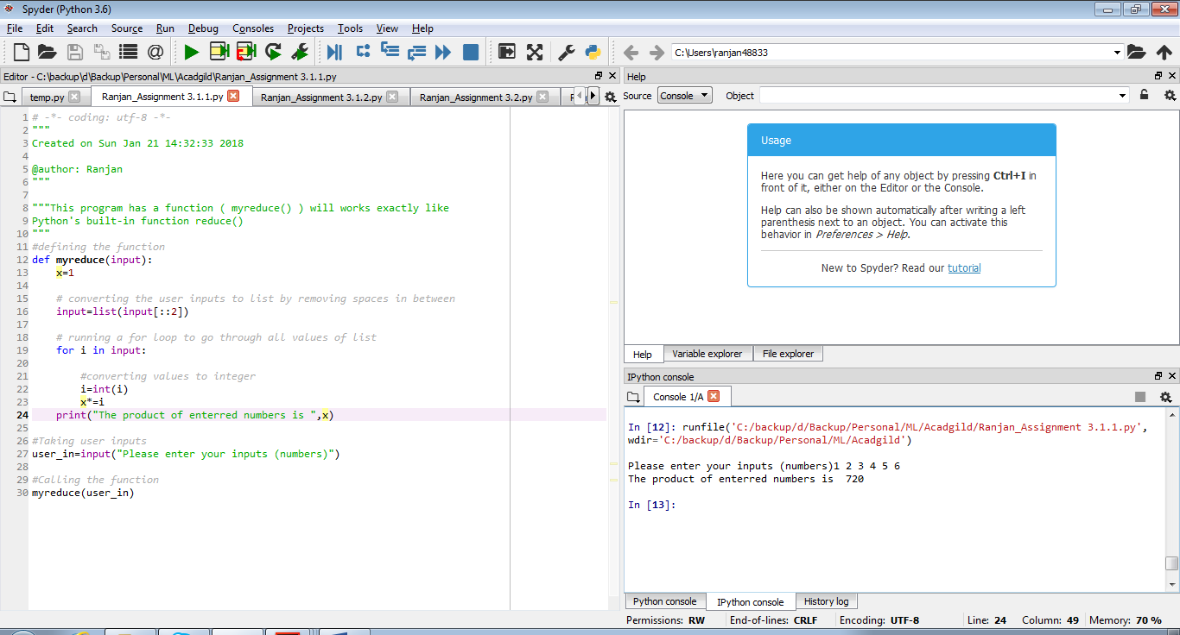

**Source Code**

#defining the function

def myreduce(input):

x=1

# converting the user inputs to list by removing spaces in between

input=list(input[::2])

# running a for loop to go through all values of list

for i in input:

#converting values to integer

i=int(i)

x*=i

print("The product of enterred numbers is ",x)

#Taking user inputs

user_in=input("Please enter your inputs (numbers)")

#Calling the function

myreduce(user_in)

myfilter()

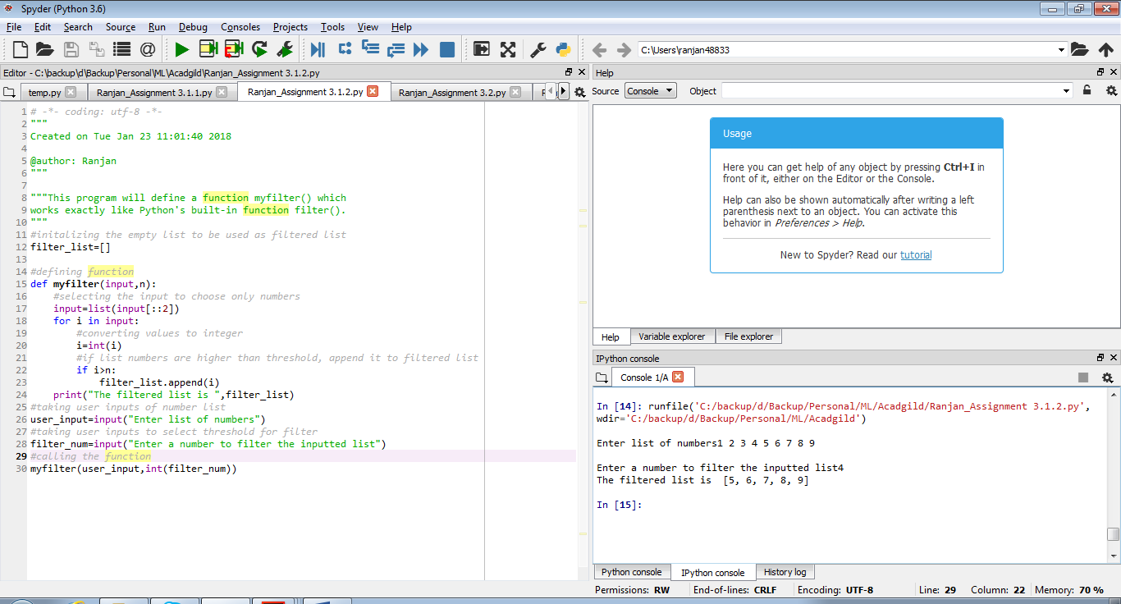

**Source Code**

#initalizing the empty list to be used as filtered list

filter_list=[]

#defining function

def myfilter(input,n):

#selecting the input to choose only numbers

input=list(input[::2])

for i in input:

#converting values to integer

i=int(i)

#if list numbers are higher than threshold, append it to filtered list

if i>n:

filter_list.append(i)

print("The filtered list is ",filter_list)

#taking user inputs of number list

user_input=input("Enter list of numbers")

#taking user inputs to select threshold for filter

filter_num=input("Enter a number to filter the inputted list")

#calling the function

myfilter(user_input,int(filter_num))